Assignment: Milestone 1



Bogazici University

SWE 573 – Software Development Practice

Assist. Prof. Suzan USKUDARLI

Prepared by: S. Erdem TURANLIOGLU

Due Date: 05.04.2022

# Overview

Goal: Creating co-learning platform on web.

There are some prerequisites for construct a platform like:

* Knowledge on python
* Knowledge on Django
* Knowledge on databases (preferably in MySQL or PostgreSQL)
* Knowledge on GitHub

As the roadmap in the course started with the learning of the fundamentals of GitHub and Wiki language. GitHub is a version control system, which is highly important to sustain a project web like step by step.

*You may find the related learning from GitHub Wiki page with given link:*

[*https://github.com/turanlioglu/bounswe573-2022/wiki*](https://github.com/turanlioglu/bounswe573-2022/wiki)

Later repositories are created, some first issues are created to understand the how GitHub work. Basically, I started to document all the learning into GitHub, also it is very useful to see what has been done so far, and what are coming in next days.

*Issue page:*

[*https://github.com/turanlioglu/bounswe573-2022/issues*](https://github.com/turanlioglu/bounswe573-2022/issues)

[*https://github.com/turanlioglu/bounswe573-2022/issues?q=is%3Aissue+is%3Aclosed*](https://github.com/turanlioglu/bounswe573-2022/issues?q=is%3Aissue+is%3Aclosed)

In week 2, we aimed to create a first project with Django. Basically, I used “djangogirls and other resources, such as Django documentaries, and for issues I faced stackoverflow” to create and follow the steps on the training project.

First problem, I faced is to creation of database. As given in class assignment, we need to use a different database (MySQL or PostgreSQL) rather than sqlite8 which supports by Django at beginning. For the sake of the class homework, I continued with sqlite8 to meet with the deadline. *Below link shows the first exercise with Django:*

[*https://github.com/turanlioglu/bounswe573-2022/tree/master*](https://github.com/turanlioglu/bounswe573-2022/tree/master)

Solution: I tried the solve the problem with MySQL by researching on the internet. However, the findings did not help me at all. Thus, I intended to try PostgreSQL and it work very well. And as I understood while I exercise with PostgreSQL, I was trying to create the database outside of the project folder, and on the other hand, the package of the PostgreSQL is in different directory. After understood that, I managed to change the database sqlite8 to PostgreSQL.

[*https://github.com/turanlioglu/bounswe573-2022/tree/main/django-postgre/postgretest*](https://github.com/turanlioglu/bounswe573-2022/tree/main/django-postgre/postgretest)

Now, the main work is doing exercises with Django as much as to learn it better.

These all were prerequisites for the actual project which will be done throughout the semester. The subject is to create a co-learning platform. As to create the platform, there will be a need of draft design of the platform and requirements.

Before requirements are defined, there should be an elicitation period to understand what is need from customer (who will use the platform).

[*https://github.com/turanlioglu/bounswe573-2022/wiki/Documentations-throughout-the-semester#w3----requirements-elicitation*](https://github.com/turanlioglu/bounswe573-2022/wiki/Documentations-throughout-the-semester#w3----requirements-elicitation)

According to the elicitation and in-class activity, the requirements and mockups as follows:

[*https://github.com/turanlioglu/bounswe573-2022/wiki/Documentations-throughout-the-semester#w4----requirements-analysis--scenarios--basic-mockup-designs*](https://github.com/turanlioglu/bounswe573-2022/wiki/Documentations-throughout-the-semester#w4----requirements-analysis--scenarios--basic-mockup-designs)

Next step is to do some exercises in Django to create multiple pages with different bases, such as profile page, registration page, log-in page, main page for the activities, creation for the spaces etc.

# List and status of deliverables

Django first project:

Basic understanding is okay, the database is set with PostgreSQL. However, there is a need to do more advanced practices, which you can see the plan under the project plan.

Requirement elicitation:

Basic elicitation questions are prepared before the class:

* Will it work with any device?
* Is it secure?
* Is it accessible?
* Does platform provide analytics?
* Does platform provide user feedbacks on a specific course?
* Does platform provide recommended courses for the user?
* Is the system being reliable?
* Will the system be free?
* Can users create learning rooms to enhance their learnings?
* Does platform provide forums for discussions?
* Will courses be in video format?
* Will courses have subject related exercises to increase the learning?
* Can user take notes into the platform while having lecture?
* Can user import/export files?
* Will system provide to course instructor to update the course material?
* Will system provide to download the course material?
* Will system show users to progress in that course?
* Will system send notification to user as a reminder to continue that course?
* Will courses have any due date to finish it?
* Will courses have curriculum of subjects?
* Will platform have any designed courses for any professions?
* Will platform sustain any certificate as a proof of course has finished?
* Will course have any graduation exam on regarding to achieve a certificate?

After in class activity, I revised and updated the requirements of the platform.

Requirements analysis:

* The system shall support web.
* The system shall have an easy registration.
* The system shall have scheduling future for meetings.
* The system shall provide users to ask & answer to the questions.
* The system shall provide voting feature.
* The system shall have calendar information that shows people schedules in the spaces.
* The system shall enable users to edit their calendars.
* The system shall enable users to send direct messages.
* The system shall enable users to send meeting invitations.
* The system shall have user profiles that users can edit with information.
* The system shall have crowd filtering for false information and harassment.
* The system shall have collaborative editing in the channels.
* The system shall have search motor for to search specific subject in the main page.
* The system shall have search motor for to search subjects in the channel.
* The channels shall support file sharing with the limit of 25 MB.
* The channels shall have multimedia message sharing.
* The channels shall have unlimited member.
* The web application shall have a learning tracking system by personally created quizzes.
* The web application shall enable users to create badges on achievements.
* The application shall send notifications to users.
* The application shall enable users to set notifications as their preferences.
* The application shall show topics to users based on their interest areas.
* The space owners shall add space prerequisites into the space information.
* The space followers shall edit space information with permission.
* The application shall have white board for taking notes collaboratively in the meetings.
* The application shall enable users to have activity performance.
* The application shall show the followers to the users.

Mockups:

The draft design is prepared for the platform.

Scenarios:

1. Source sharing

In room, people may share unrelated sources with the others. And this may create a complexity on searching the needed source or every added source may notify people too much.

1. Spams

Some people, who are unrelated with the space, may enter the area for advertisement purposes. These kinds of people just different kind of announcement, which may affect the working in the environment.

1. Silent users in the room

The participation is important to sustain and when it is a co-learning platform, people contribute the space with their knowledge to help other people to learn & understand more on the space subject.

1. Link sharing

Platform should enable to share links, but of course links should not contain any corrupted information.

1. Mapping tools for to save the discussion notes

Tools should be added to the space and these tools should have different kind of features to highlight important notes, such as different use of colors, different typing styles, diagrams, bulletins etc.

1. Team meeting scheduler

One of the most effective ways to learn is to have group discussions, so that the group members should set a weekly meeting to gather and discuss on week's subject, for that reason there may be need of a scheduler and a video chatting extension. While video chatting, there may be need to screen sharing, note taking tools to save the ideas or show it to the others. Meanwhile, the chatting feature is also important to discuss not just with a voice or also in text. Finally, polling can be necessary to get member feedback on specific discussions to see what the general idea on the subject is.

Note: Some scenarios are not applied to the mockup design, in future these can be added or subtracted.

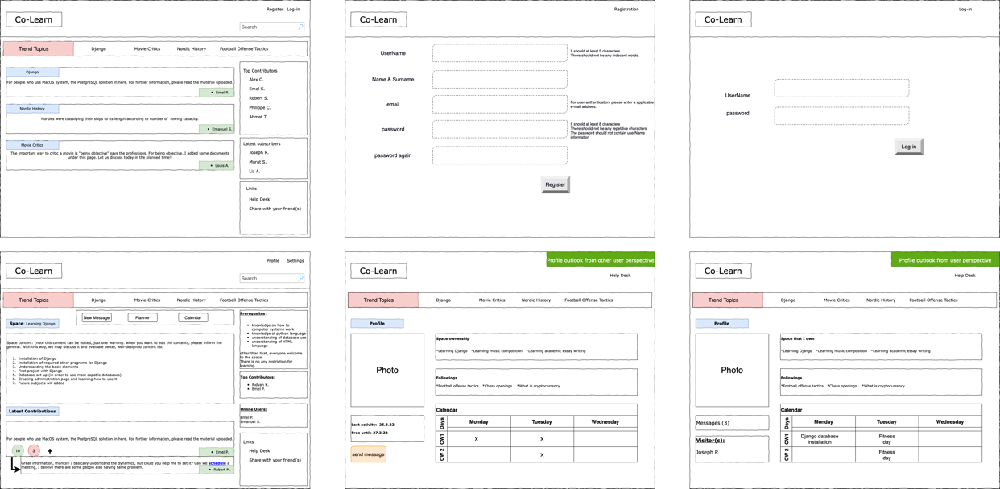First design:

Second design:

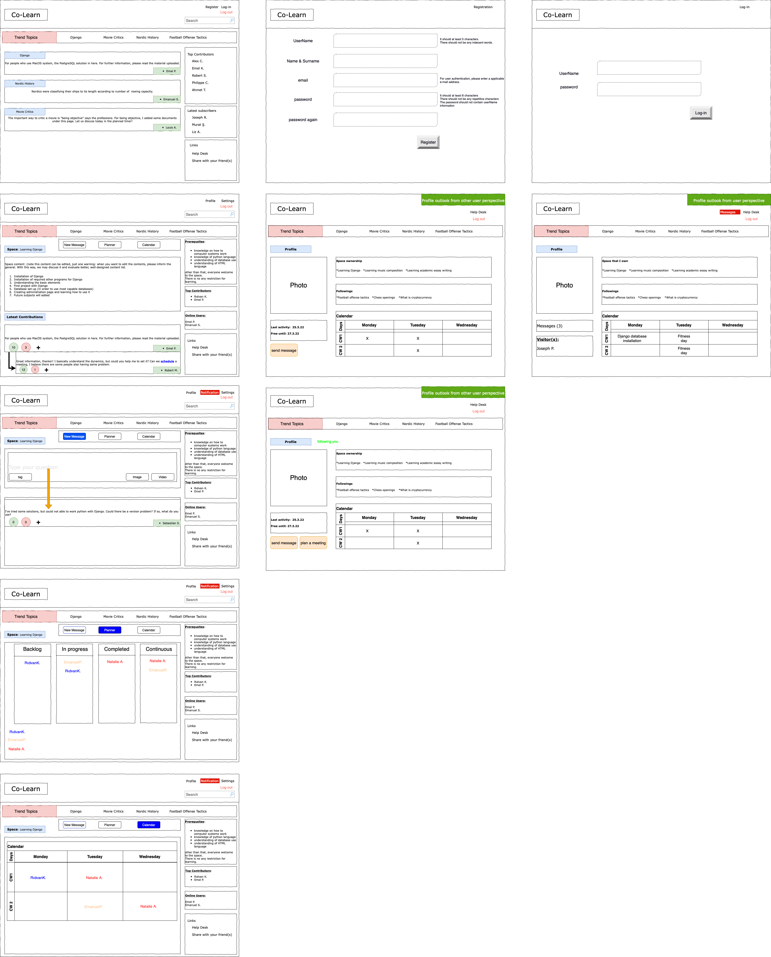

In planner and calendar views under names, it will show the subject name that is related with those columns.

For instance:

In planner page, Rıdvan K. has two subjects one in “backlog” and the other one under “in progress”. Those indicates the issues that Rıdvan K. need to do according to his plan.

Third design – added features will be shown in below.

Inbox view:

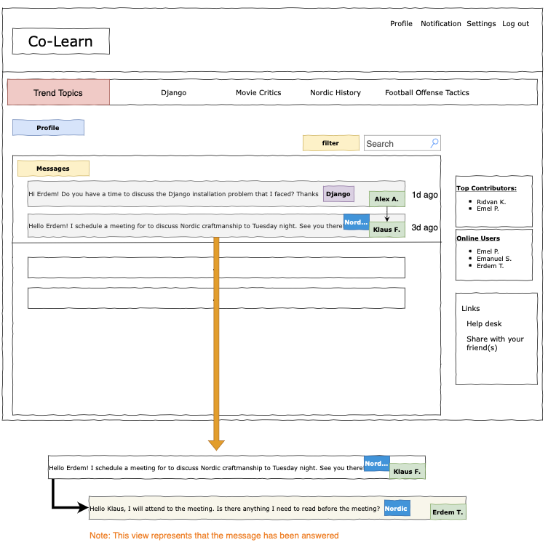

Notification window:

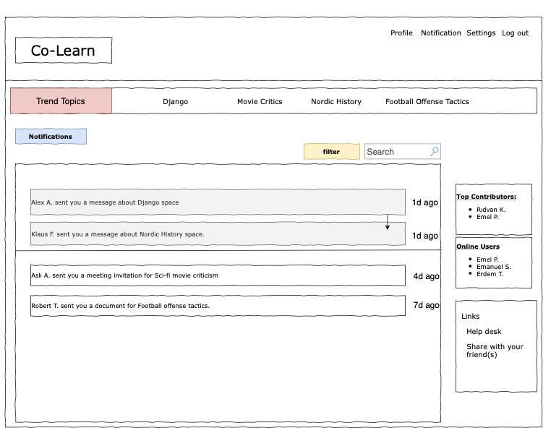

Help desk view:

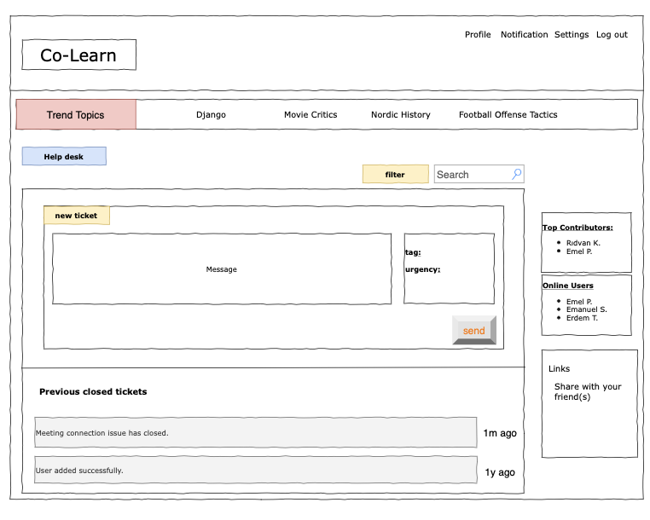

<https://github.com/turanlioglu/bounswe573-2022/tree/main/deliverables>

* Software design documents in UML

Use case diagram:

User’s potential interactions in the co-learning platform.

It is drawn related to one user’s perspective.

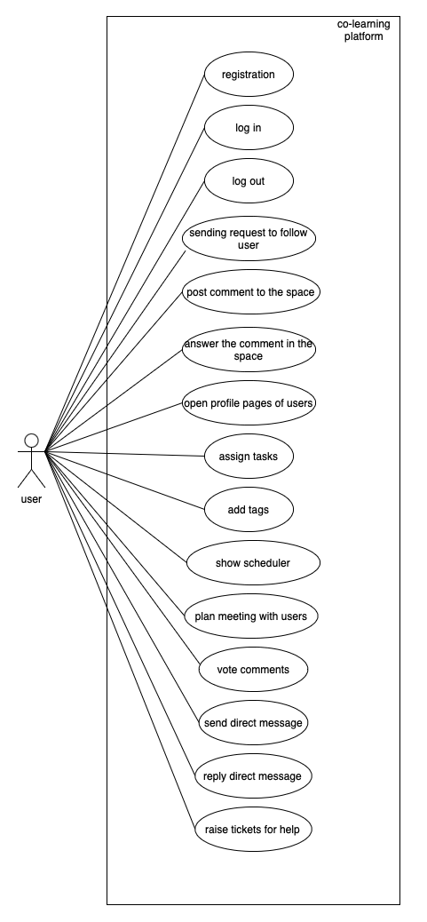

Registration: Users need to be registered to be part of the co-learning system. For registration, they need to have a unique username and password. They are required to enter their name, surname, and e-mail addresses to be registered.

Log in: Users may sign in by entering their unique username and password, which has been used in the registration step, in main page. Before entering the site, user need to use to continue.

Log out: Users, who have been signed may sign out by clicking sign out button that exist in every pages.

Sending request to follow users: Users may want to follow other users with same interests. For that, he/she need to click the follow button in user’s profile page.

Post comment to the space: Users may raise new questions or comments to the space. Users can click the button in space main page under trend topics banner.

Answer the comments in the space: In each comment or question, there is a “+” button that users can add comments regarding to the question or comment, or they can answer it.

Open the profile page of user: Users may open the user’s profile page, whom they may have common interests. In space main page, users can see the “top contributors” and “online users” list on the right-hand side. Users can click to the names to open the profile pages.

Assign tasks: Users may assign tasks to themselves to make learning with an iterative way. Also, they may return to that issue when its needed. In the space main page, the planner tab can be found.

Add tags: Users can add tags while they send messages to the space or in the planner page, when assign tasks to themselves for filtering easily when needed.

Show calendar of users, who are in the space: Users may open the calendar page with clicking calendar button in the space main page to see that planned meetings or schedule of users to plan any meeting with them.

Plan a meeting with users: Users may plan meetings with other users to discuss a topic or learn from others. In calendar, users can see empty slots to create new meetings.

Vote user comments: Users can vote the comments regarding its helpful or not. On the comment area, there are green and red icons to up/down vote.

Send direct messages: Users may want to send direct messages to other users to ask about specific questions. In user profile page, the message button can be found. Although, for sending messages to people, these two people should follow each other.

Reply direct messages: When a user got a new message, “notification” button will show that he/she got a new message. To read it, the user needs to click it.

Raise tickets for help: When there is a system problem, user can raise a ticket to IT desk for help. “Help desk” button can be found in the user profile page.

Class diagram:

Describes the structure of the system by showing system’s classes, their attributes, methods, and the relationships among the objects.

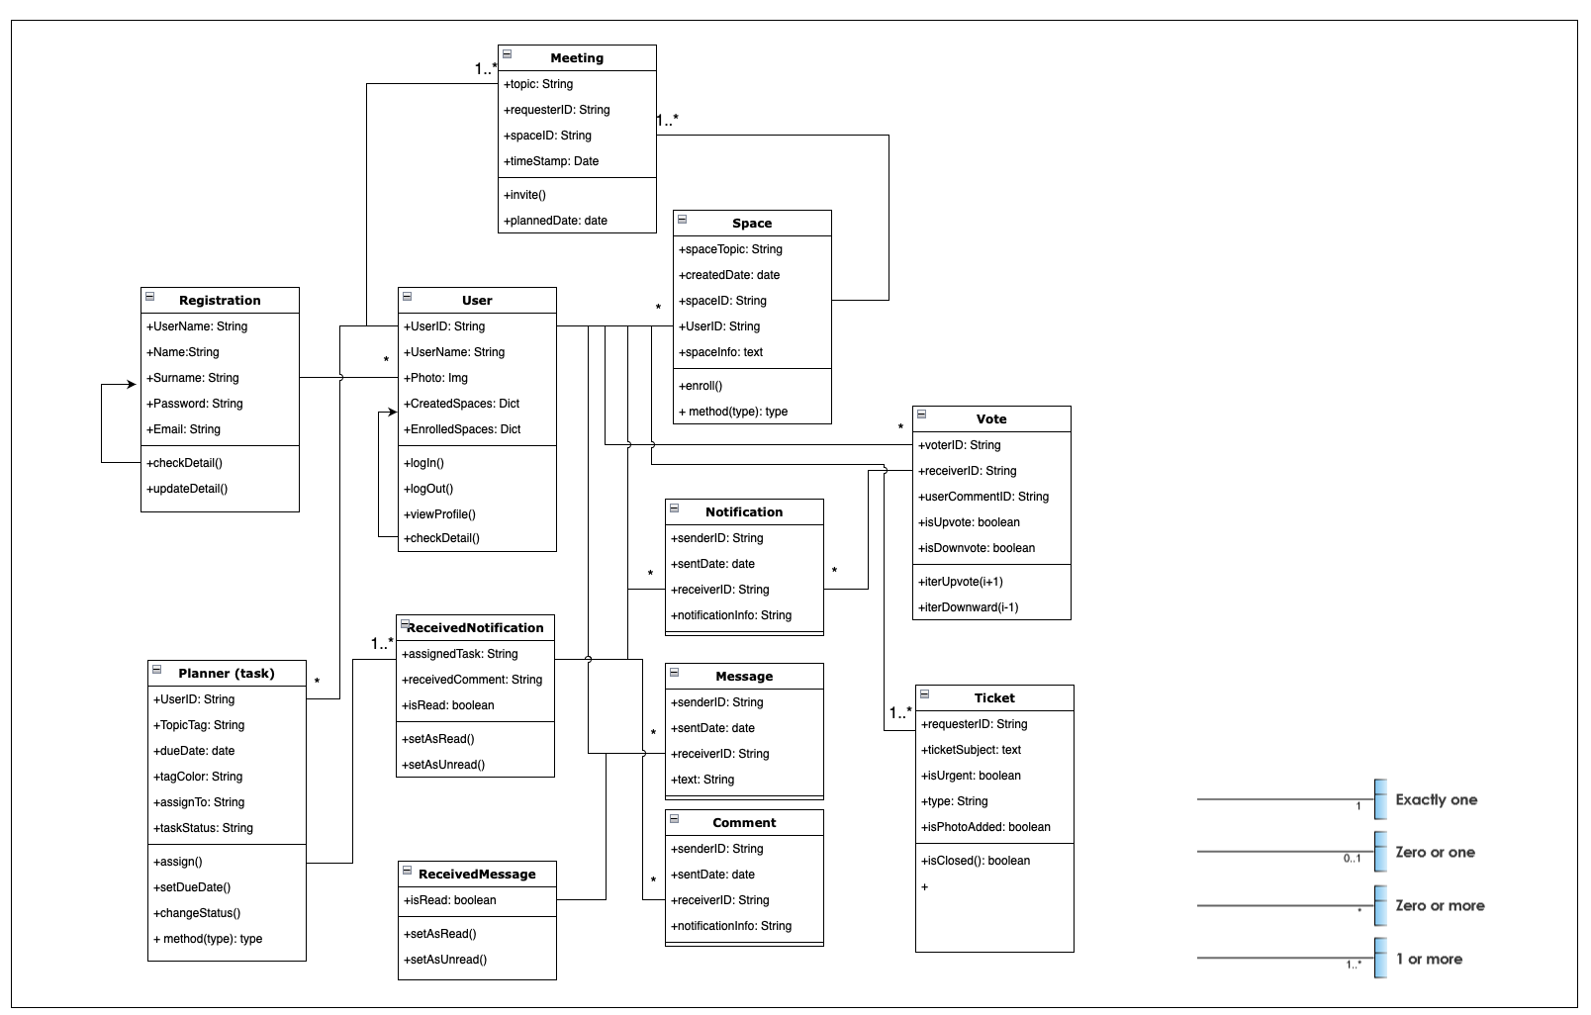

+followUser()

Sequence diagram:

Registration

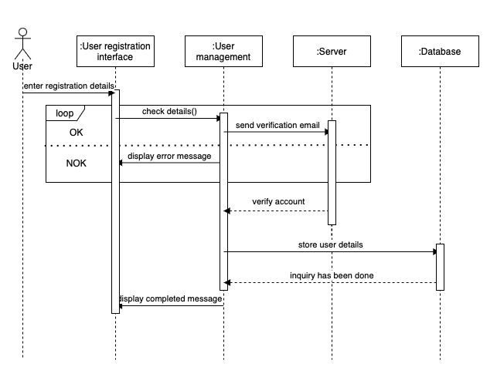

Log in

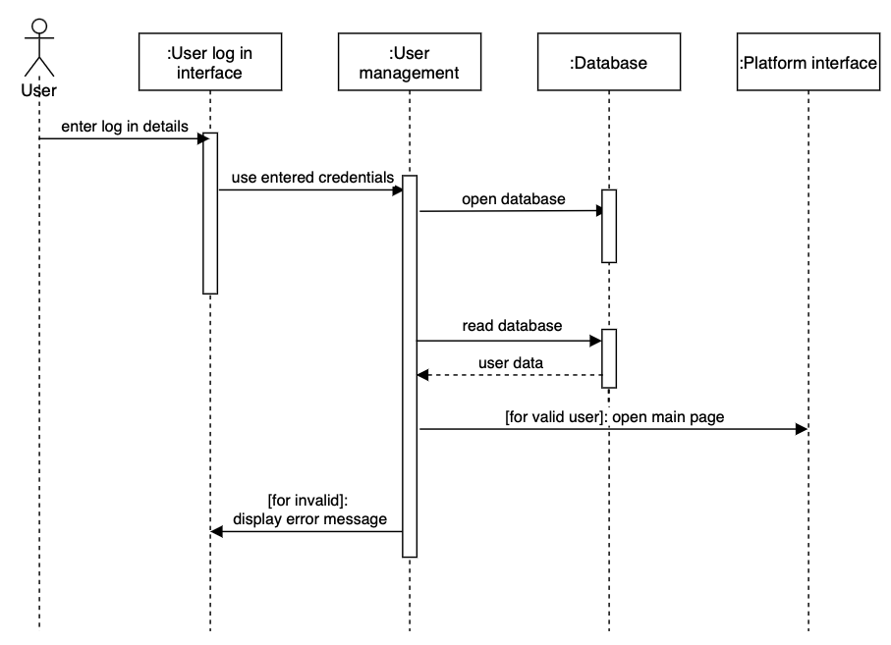

Log out

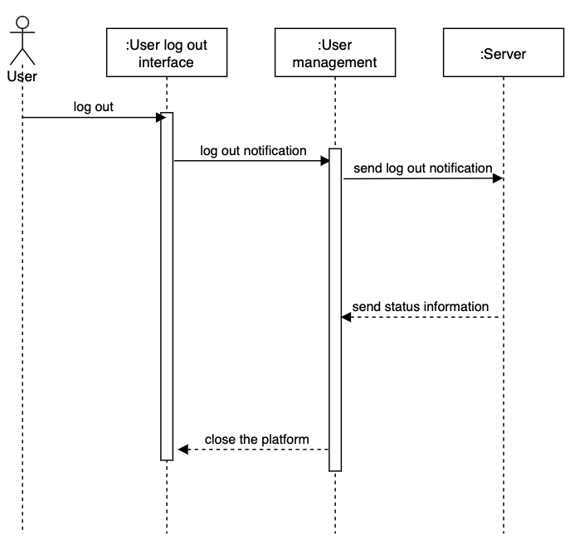

Sent request to follow user

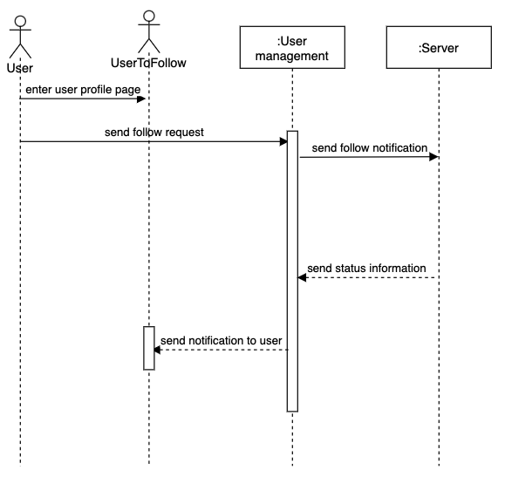

Post comment

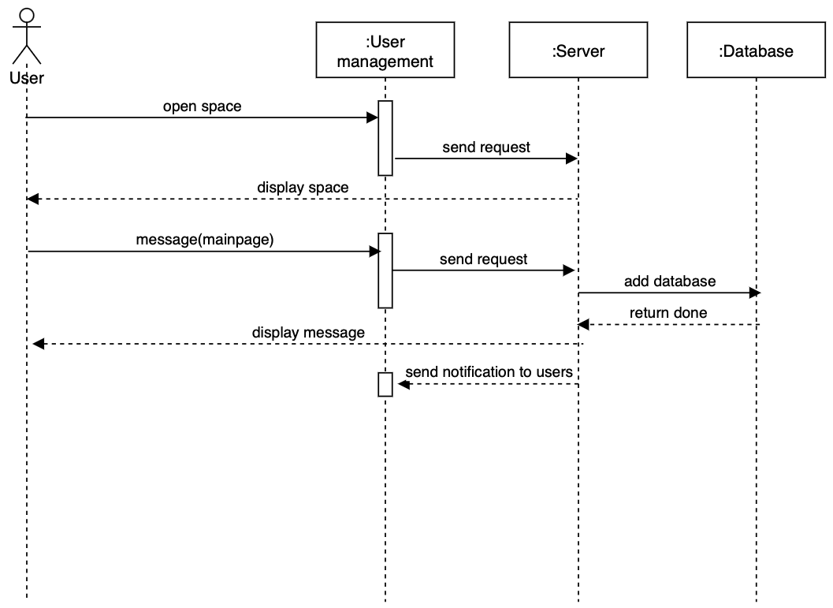

Answer comment

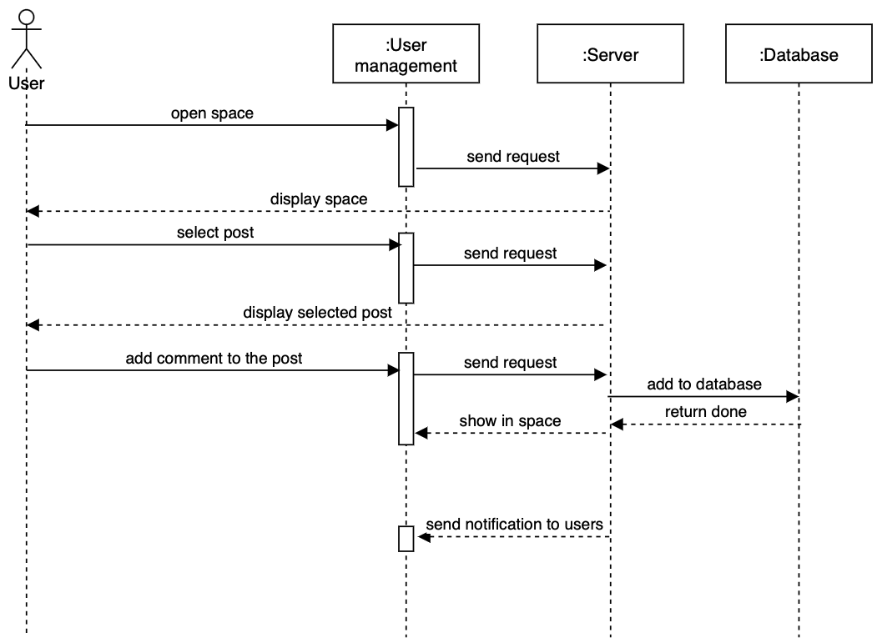

Open profile page

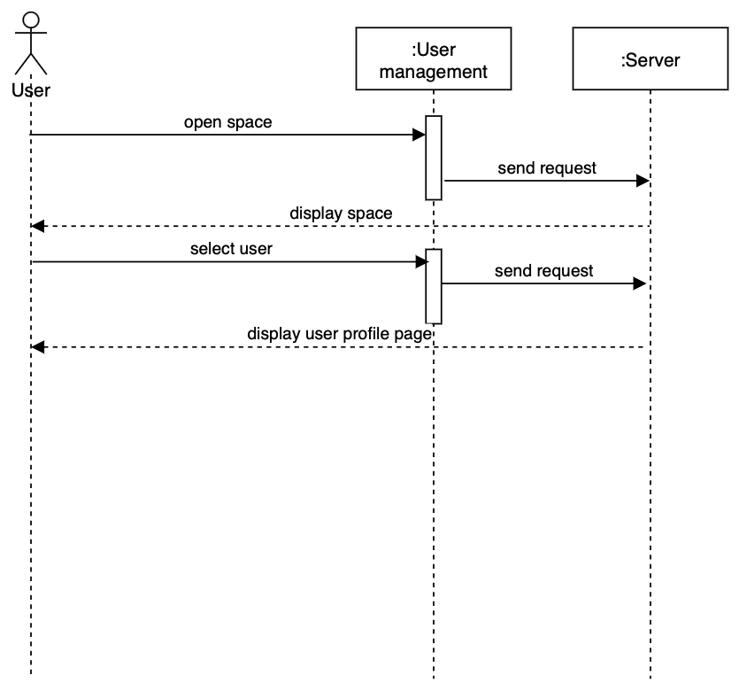

Assign task & add tag

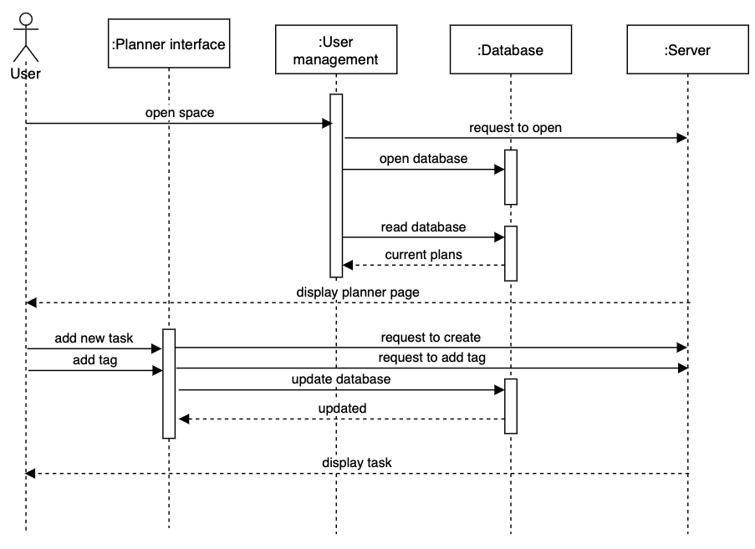

Schedule a meeting

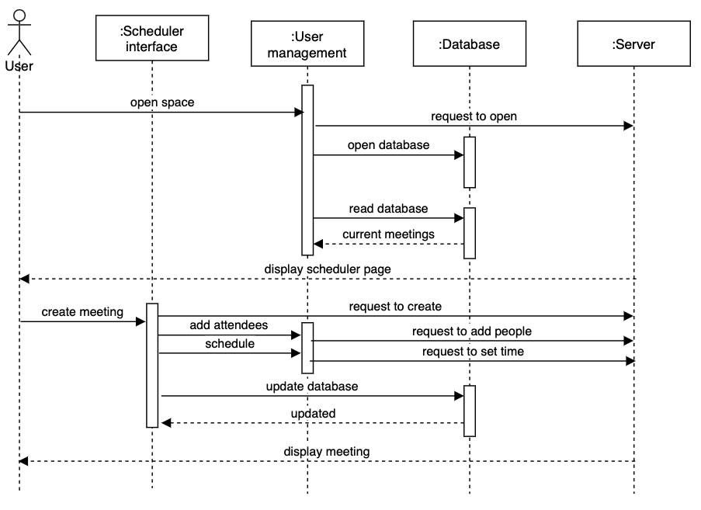

Vote

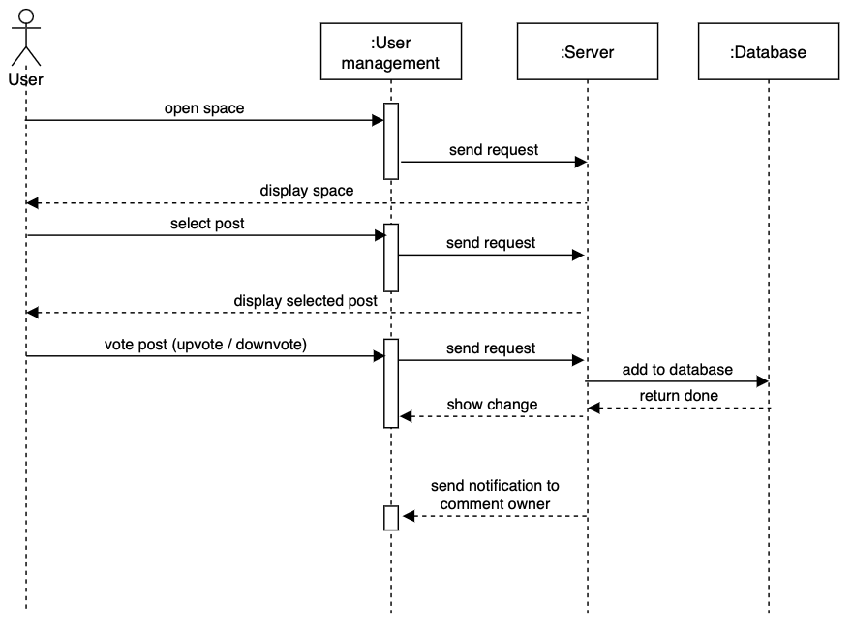

Direct message sent & reply

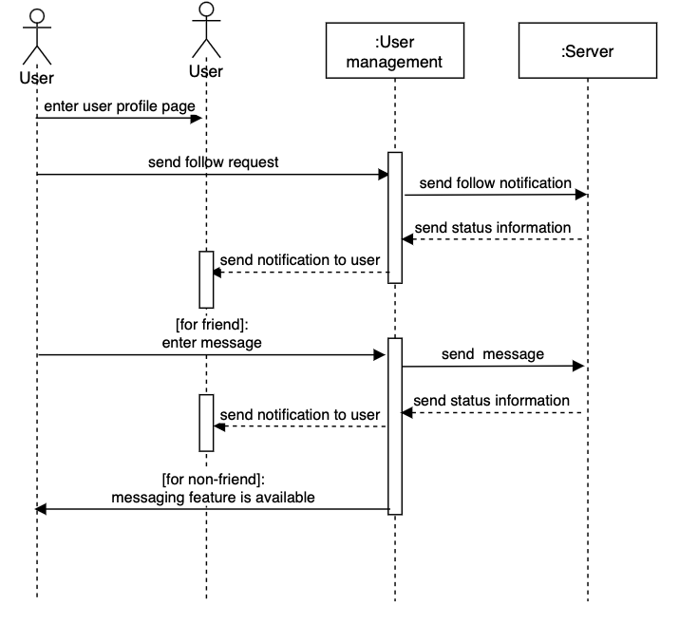

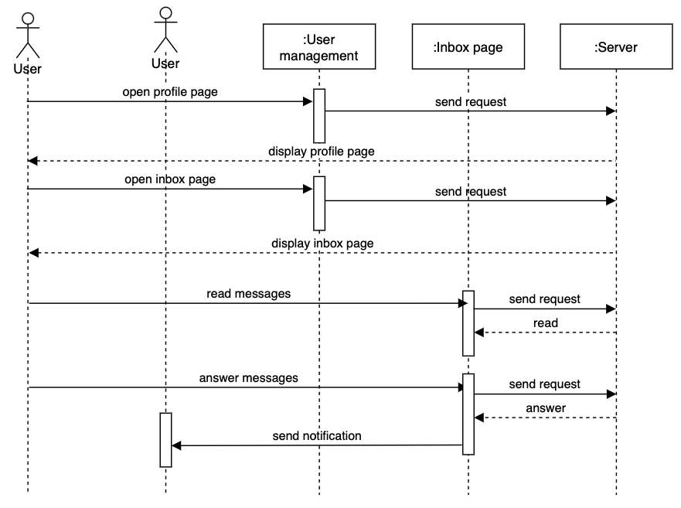

Help desk

tablo içeren bir resim

Açıklama otomatik olarak oluşturuldu

* Project plan

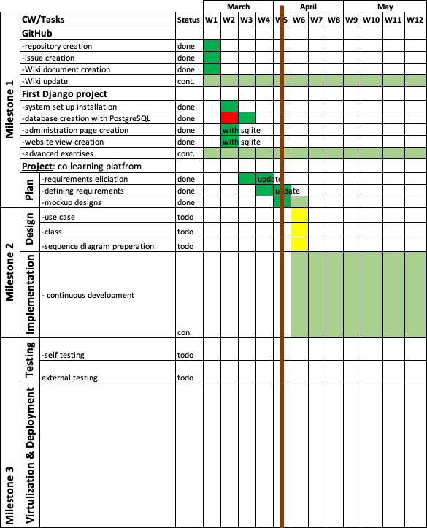

**Evaluation of the status of deliverables and its impact on your project plan**

* First project with Django

The project baseline was installation of the needed programs into our computers. This has done perfectly. Later, at the database set up I faced with a problem which MySQL is not worked and returned error messages. After researched the problem, people faced same issue with me, and the root cause is the MacBook M1 silicon chip OS is not suitable for the MySQL and Django connection.

This problem led me to work on more to fix the problem and faced one week delay in my plan. Later, I worked on PostgreSQL, and it went well, successfully installed.

* Requirements elicitation

I’ve searched similar co-learning platforms and tried to understand the design of these websites with trying some features of them.

The sites, I have looked: Coursera, Accenture, Udemy

After in-class activity, updated problem set that I prepared earlier.

* Requirements analysis

As elicitation phase, based on my experiences in those sites, I list potential requirements for the co-learning platform.

Scenarios and mockup designs

At first, the scenarios were in textual format, did not sketched them.

However, after class activity, related to given examples in class I updated my previous work and add them in this report.

So far, there is no backlog in project plan. However, there is a need to do more advanced exercises with Django environment.